**Online Certification Course Details:**

**BLOCKCHAIN BASICS:**

**Today I started with Week4 & completed 2 lessons:**

#### Decentralized Systems

#### Consensus Protocol

**And took quiz on these lessons**

**SNAPSHOTS:**

#### Decentralized Systems

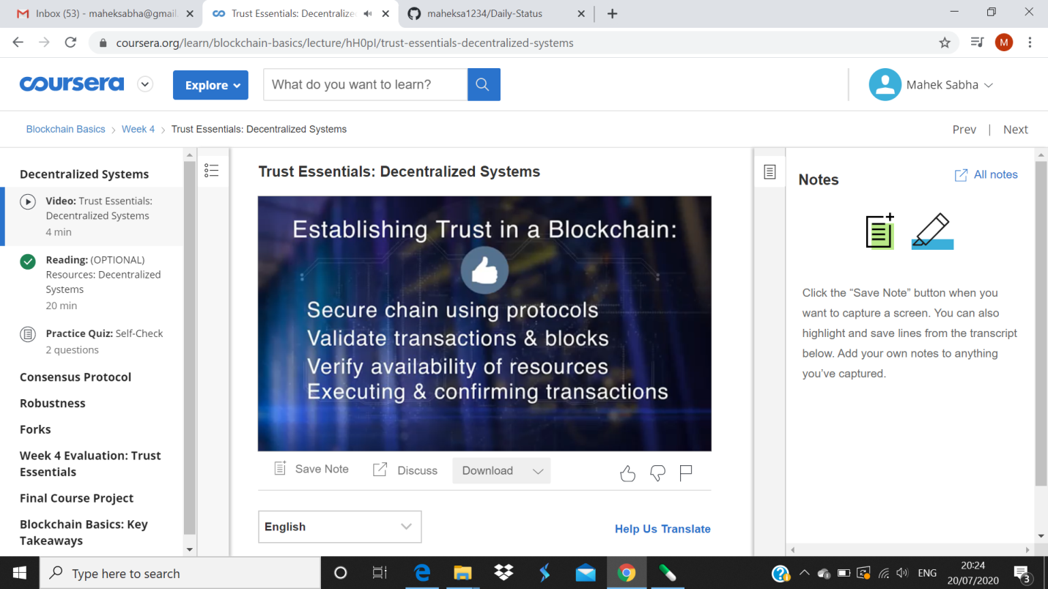

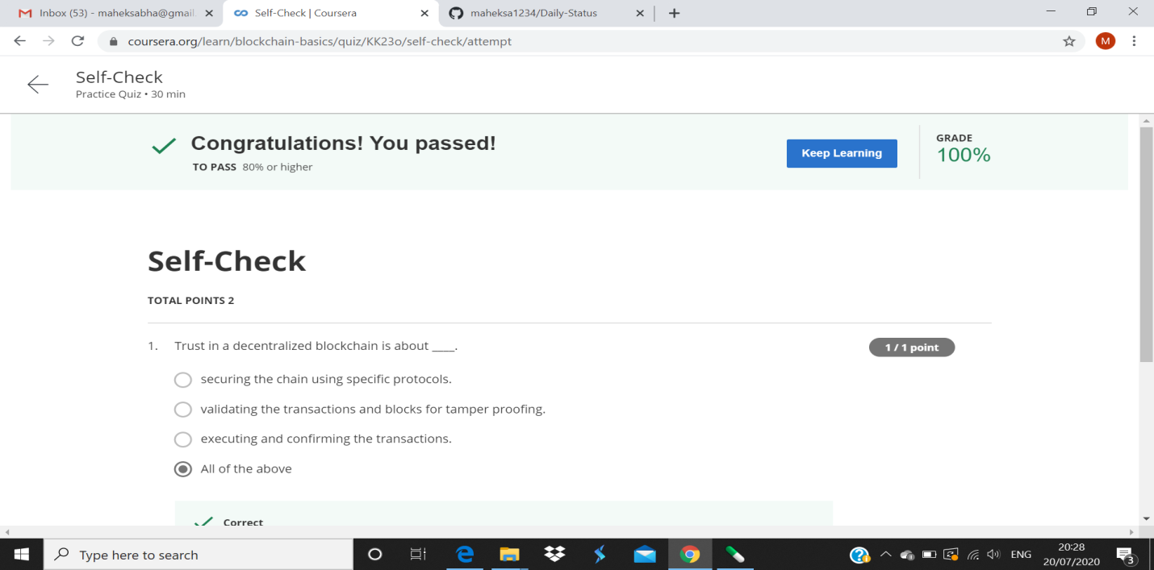

#### Consensus Protocol

